- To work with git hub first download using the following link
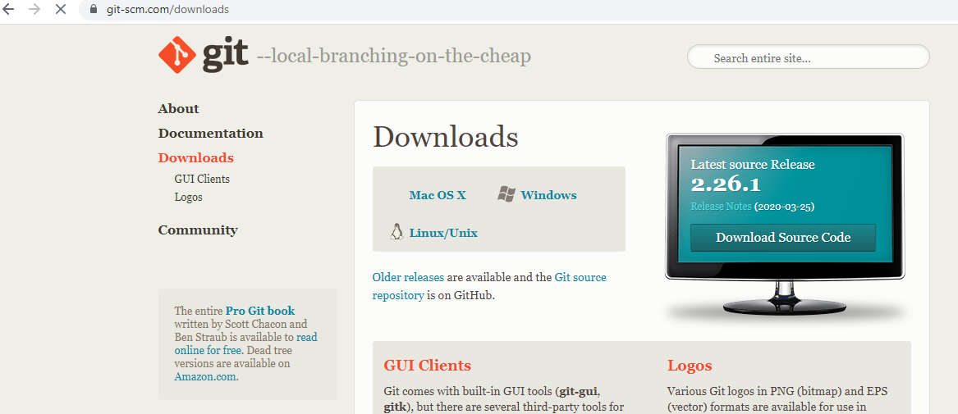

- Go to C:\Users\home\sagar (new folder sagar created)
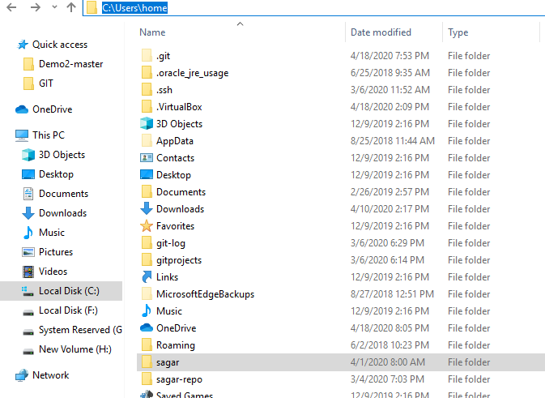

- Now to go command prompt and type git bash
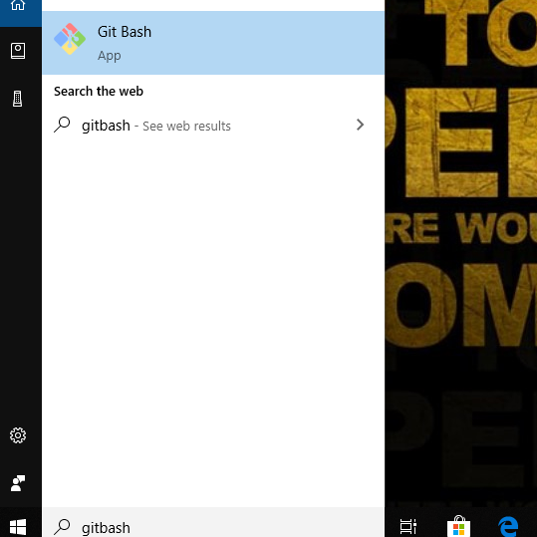

- Go to git bash command prompt and type the following
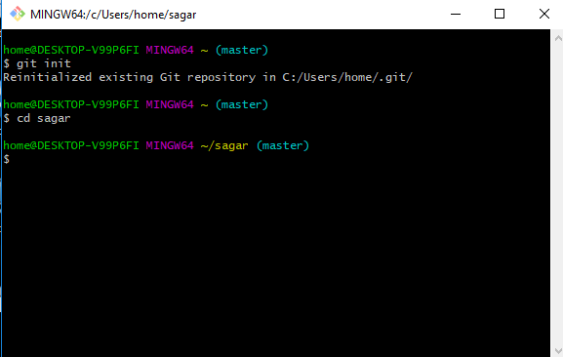

- Next perform git clone to downloads documents through online by using link and press enter
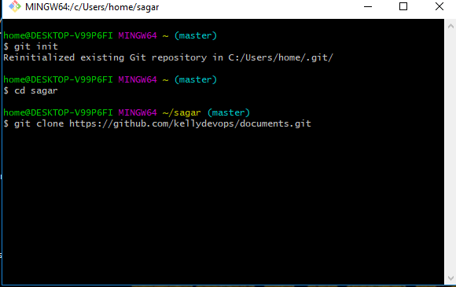

- Once u perfom this step all the documents in that will be downloaded to sagar folder
